**HTML Audio**

The HTML <audio> element is used to add audio content to a webpage, allowing you to play music, sound effects, or other audio files directly in the browser.

**Syntax**

<audio>  
 <source src="sample.mp3" type="audio/mpeg">  
</audio>.

<!DOCTYPE html>

<html lang="en">

<body>

  <audio>

    <source src="audio.mp3" type="audio/mp3">

    <source src="" type="audio/ogg">

  </audio>

</body>

</html>

**Output:**

*The <audio> supports the* [*global attributes*](https://www.geeksforgeeks.org/html-global-attributes/) *and* [*event attributes*](https://www.geeksforgeeks.org/html-event-attributes-complete-reference/)*.*

**Functionality of HTML Audio**

* The [controls attribute](https://www.geeksforgeeks.org/html-controls-attribute/) adds play, pause, and volume controls to the audio player.
* The [autoplay attribute](https://www.geeksforgeeks.org/html-autoplay-attribute/" \t "_blank) makes the audio play automatically when the page loads.
* The [loop attribute](https://www.geeksforgeeks.org/html-loop-attribute/) makes the audio play continuously, repeating the file.
* The[src attribute](https://www.geeksforgeeks.org/html-src-attribute/) defines the URL of the audio file.
* The [muted attribute](https://www.geeksforgeeks.org/html-muted-attribute/)silences the audio when the page loads.

**HTML Audio Media Types**

* The [mp3 file format](https://www.geeksforgeeks.org/mp3-file-format-mp3-extension/) with media type audio/mpeg.
* The [ogg file format](https://www.geeksforgeeks.org/what-is-ogg/) with media type audio/ogg.
* The [wav file forma](https://www.geeksforgeeks.org/wav-audio-format/)t with media type audio/wav.

**More Examples of HTML Audio**

**Basic Autoplay Audio**

<html lang="en">

<body>

  <audio controls autoplay>

    <source src="audio.mp3" type="audio/mpeg">

  </audio>

</body>

</html>

**Output:**

**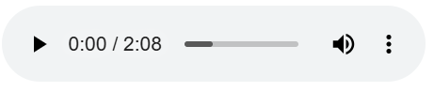**

* The <audio> element includes the autoplay attribute, causing the audio to play automatically upon page load.
* The <source> element specifies the audio file's URL and its MIME type.

To learn more about the HTML audio autoplay attribute, click here [Link](https://www.geeksforgeeks.org/html-autoplay-attribute/)

**Autoplay Audio with Controls and Styling**

<!DOCTYPE html>

<html lang="en">

<head>

  <style>

    audio {

      display: block;

      margin: 20px auto;

      width: 80%;

    }

  </style>

</head>

<body>

  <audio controls autoplay>

    <source src="audio.mp3" type="audio/mpeg">

  </audio>

</body>

</html>

**Output:**

**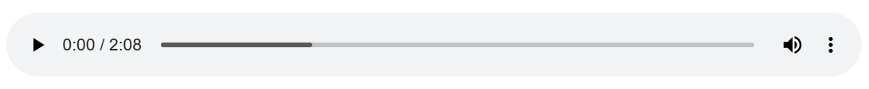**

* The <audio> element includes both controls and autoplay attributes, providing playback controls to the user while starting the audio automatically.
* The CSS styles center the audio player on the page and set its width to 80% of the container, enhancing its appearance.

**Best Practices for HTML Audio**

* Provide multiple audio formats to ensure compatibility across different browsers.
* Include the controls attribute to offer users playback options like play, pause, and volume control.